Breast Presentation Answers.
- Describe this image
Medial
side
superior
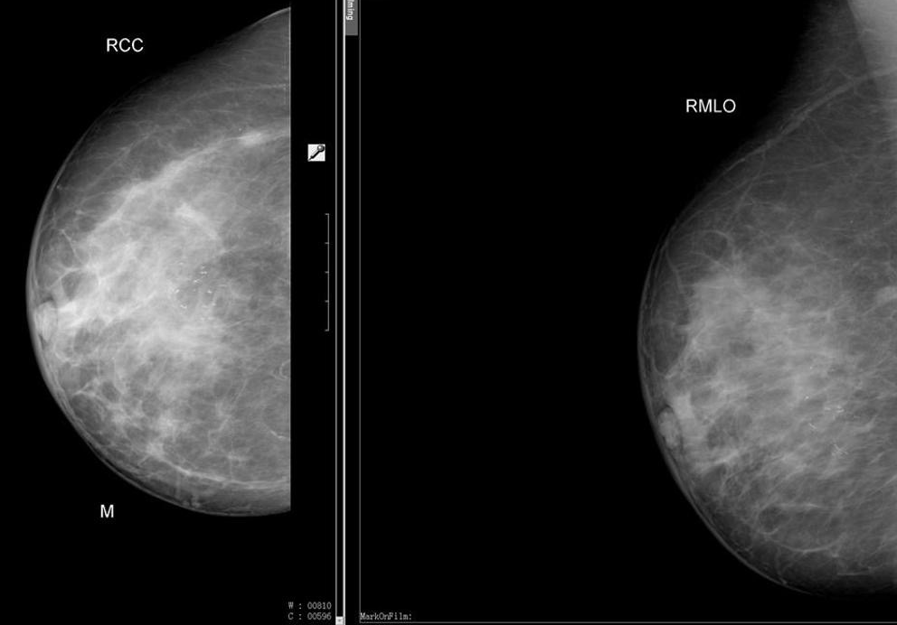
These are mammographic images of a right breast. These represent the standard cranio-caudal (CC) and mediolateral oblique (MLO) views. The MLO view can be distinguished by the presence of the pectoral shadow.
- How do you describe mammographic lesions? (Shape, margin, density and microcalcifications)
  - Location: which quadrant, deep or superficial
  - Number of lesions
  - Shape: Round or oval shapes are typically benign (fibroadenoma or cyst). Lobulated or irregular masses are typically malignant.
  - Margins: circumscribed are benign, while margins suspicious for malignant lesions are microlobulated, obscured, indistinct or spiculated, with outlines destroying tissue planes.
  - Microcalcifications large, running in lines are benign, while pleomorphic or heterogeneous, fine and branching calcifications have a high probability of malignancy.

- What are the ultrasound features of benign and malignant breast lesions?
  - Benign features include elliptical shape, hyperechogenicity or anechoic, smooth, and well-circumscribed margins.
Cysts are oval or round, well circumscribed, anechoic with posterior acoustic enhancement.
  - Features of malignancy are irregular margins, hypoechoic to the surrounding tissue . Malignant masses are usually taller than they are wide an destroy tissue planes.

- Describe the images
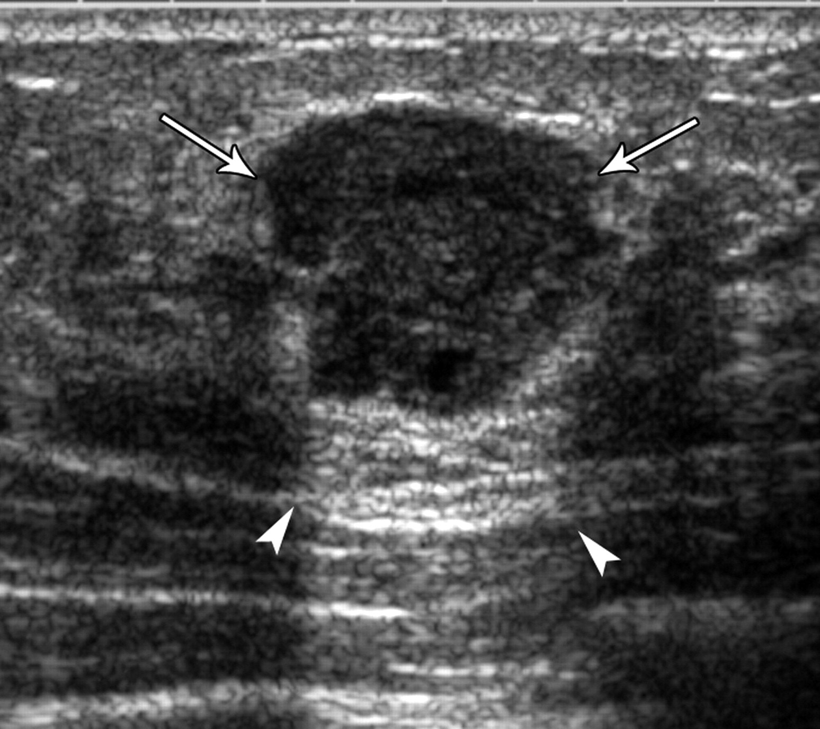
Ultrasound image showing a hypoechoic lesion with shadows inside indicating a solid lesion rather than cystic, slightly irregular, could be a fibroadenoma but can not exclude a malignancy, biopsy is required

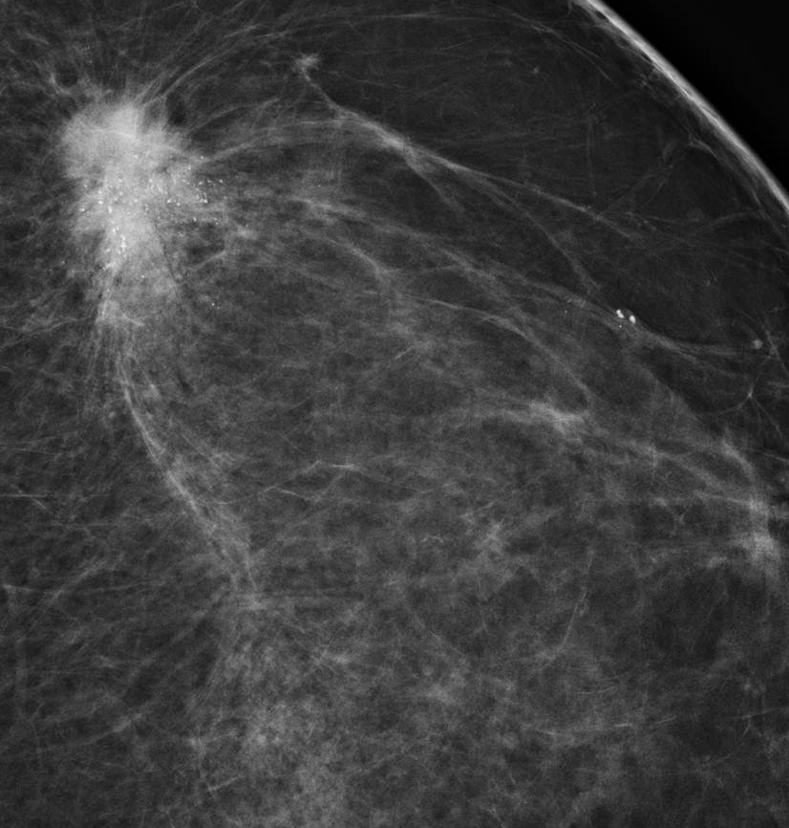
Mammogram showing a speculated lesion with microcalcifications, this is a malignant looking lesion

- How do you perform an FNA and how are results reported?

  - FNA uses a 22G needle and a syringe (aspirated to include few ml of air), needle is passed several times into the mass if clinically apparent or using ultrasound guidance.
  - The material in the needle is then usually fixed on a slide, or into specific solution (cytospin).
  - It has a false positive rate <1%, a false negative rate <10%. Insufficient material for diagnosis occurs in about 10% of cases.
  - The presence of cancer cells does not differentiate between invasive and in situ cancer.
  - FNA results are reported as:
    - C1 — inadequate/acellular C4 — suspicious or
    - C2 — benign C5 — malignant.
    - C3 — atypical
- How do you perform a core biopsy?
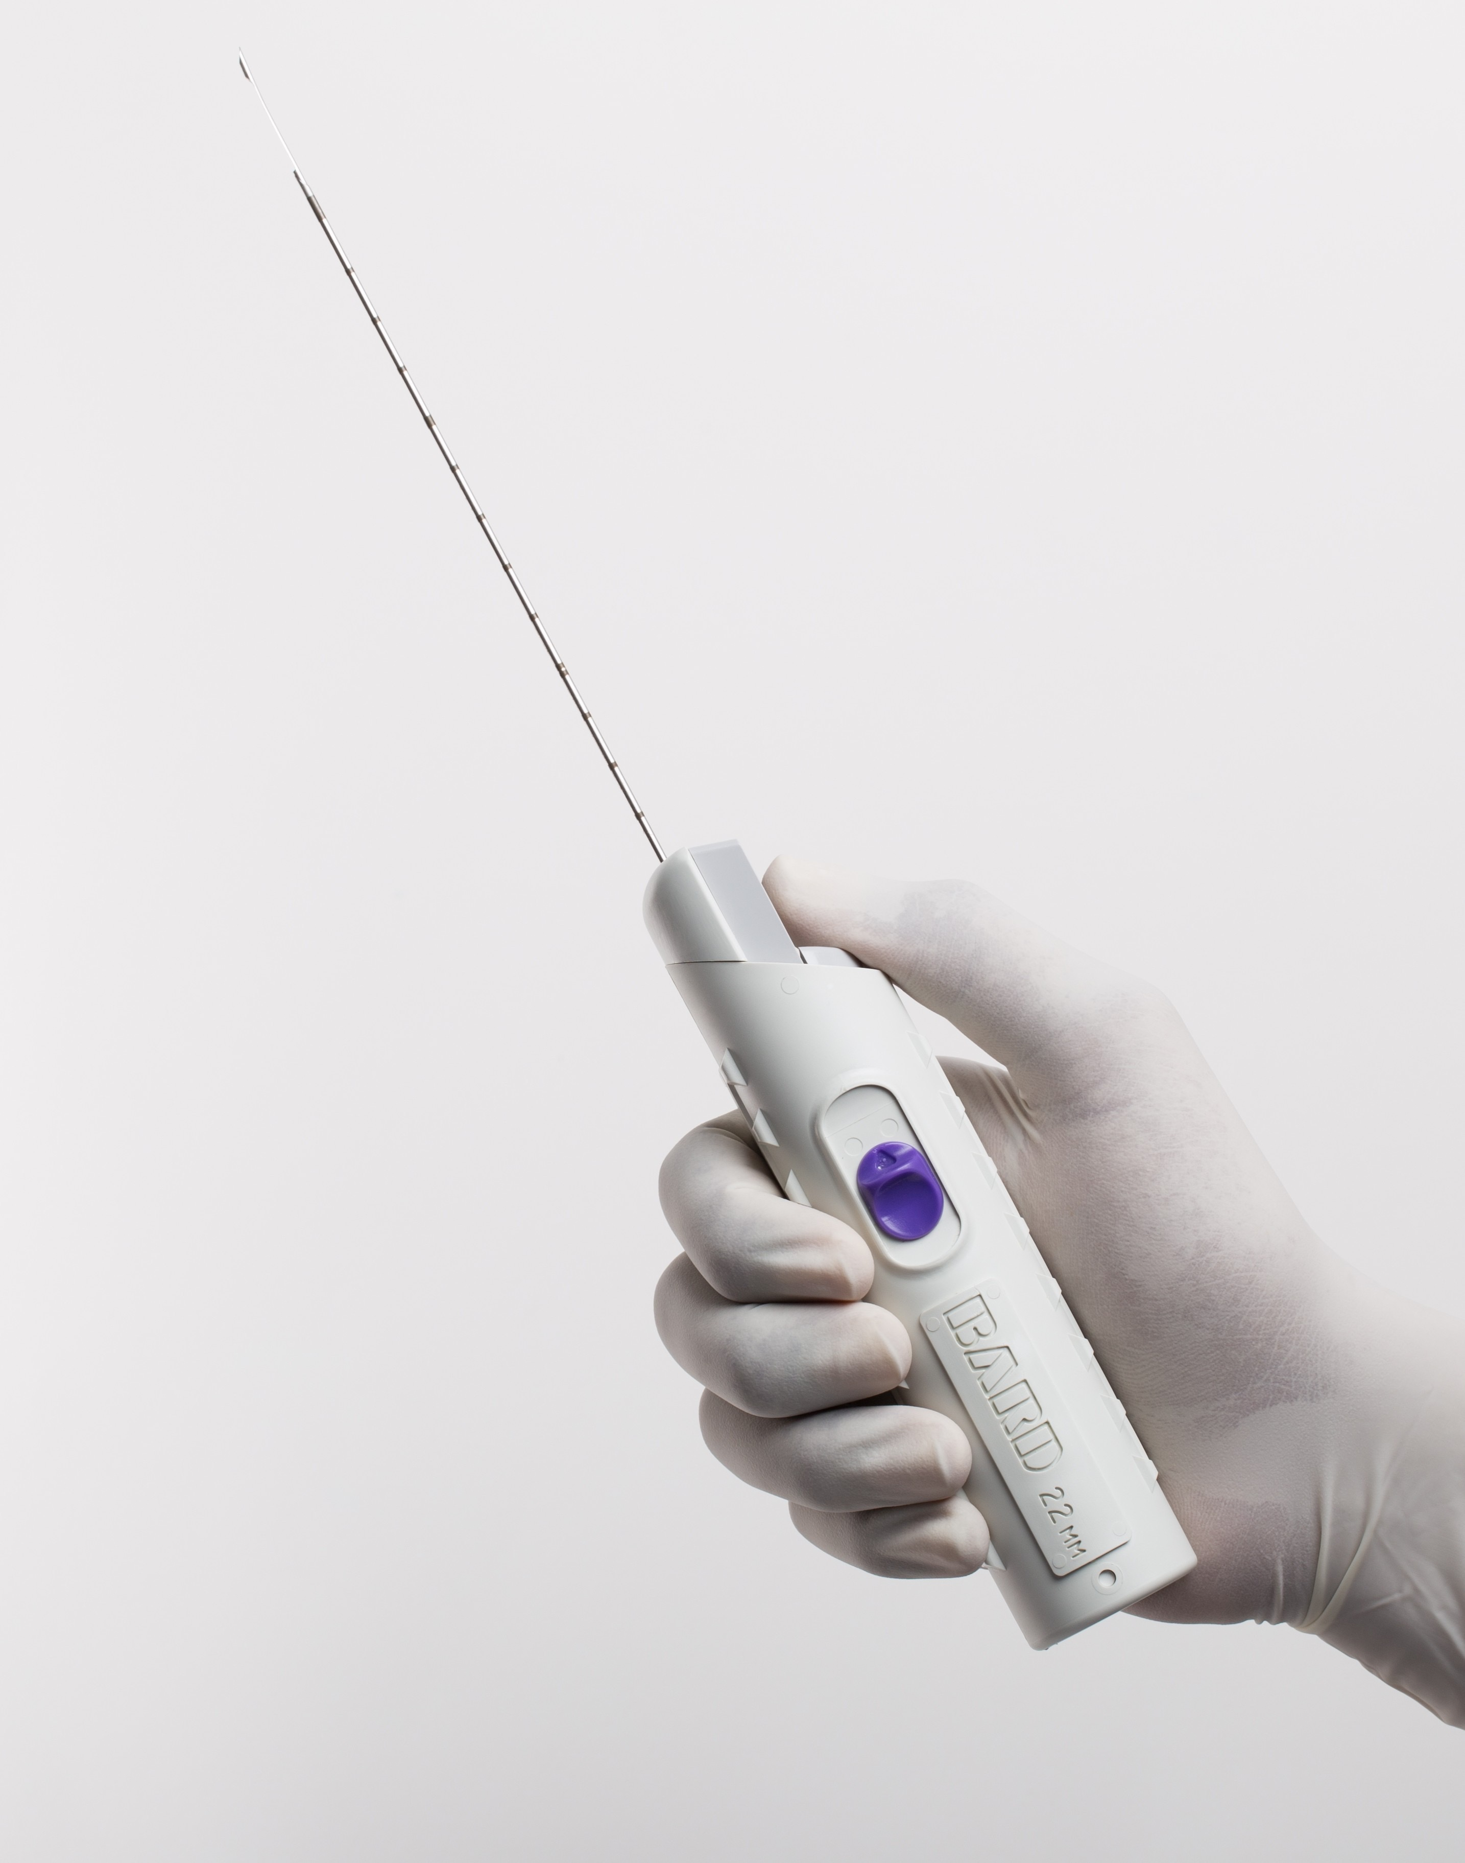
  - Conventional core biopsy uses a spring-loaded biopsy gun unseeing a double-action needle (typically 14G) consisting of an inner trocar with a sample notch and an outer cutting cannula.
  - To obtain the specimen the needle must be withdrawn. Usually, 4–6 samples are taken (4–6 insertions).
  - Core biopsy provides a diagnosis of histological type, grade, hormone receptor status, HER2 expression.
  - Core biopsy differentiates ductal carcinoma in situ (DCIS) from invasive cancer.

- A 62 Y old with this lesion in the breast. What is your approach to treatment?
  - Treatment should be discussed at an MDT with medical and radiation oncologists involving review of the pertinent radiology and pathology.
  - Four modalities of treatment to be discussed: Surgery, Radiotherapy, chemotherapy, hormonal.
  - It should be considered within three dimensions:
    - treatment of the breast
    - staging and treatment of the axilla
    - systemic treatment

- What is the treatment for the breast itself?
  - Mastectomy (with/without immediate or delayed reconstruction)
  - Wide local excision (WLE) with clear margins combined with post-operative radiotherapy

- What are the treatment options for the axilla?
  - If the axilla is clinically or radiologically positive (palpable nodes or abnormal on Ultrasound), then a core biopsy or FNA should be performed. If cancer is confirmed then axillary lymph node dissection (ALND), generally to level II, will be required.
  - If the axilla is clinically and radiologically negative then a staging procedure is required. Options are: sentinel lymph node biopsy (SLNB) which largely replaced the axillary lymph node dissection.

- What systemic treatments for breast cancer are you aware of?
  - Chemotherapy
  - Hormone therapy

- What is the role of adjuvant endocrine therapy?
- Adjuvant endocrine therapy reduces the chance of local of distant recurrence by approximately 50%. The absolute risk reduction for an individual patient can be estimated using online assessment tools such as NHS predict
  - Tamoxifen is generally offered if the cancer is ER/PR positive for both pre and post menopausal women, it should be taken for 5 years (possibly 10). Its use is associated with increased risk of endometrial cancer (excess mortality 1–2/1000), DVT/PE (4:1000), stroke, flushing, vaginal dryness, weight gain, nausea, disturbances hair and nail growth and reduced metabolism of warfarin.
  - Aromatase inhibitors (such as anastrozole) more effective in post –menopausal women. They cause bone resorption so patients should have a bone density scan before commencing treatment and if they have osteoporosis then should either have bone protection medication or use Tamoxifen instead. Other side effects are similar to Tamoxifen with the exception of DVTs. They also cause small joint pain

- What is the role of adjuvant chemotherapy?
- chemotherapy works by targeting tumour cells that have metastasized to other sites in the body but are too small to be detected by imaging.
  - Chemotherapy produces a relative risk reduction (RRR) of recurrence and of death. However, the absolute benefit depends on the risk of recurrence or death for that patient with those with the highest chances of recurrence receiving greatest absolute benefit.
  - Women under 70 years with node-positive disease should be offered adjuvant chemotherapy, but the benefit is greatest in women under 50 years.

