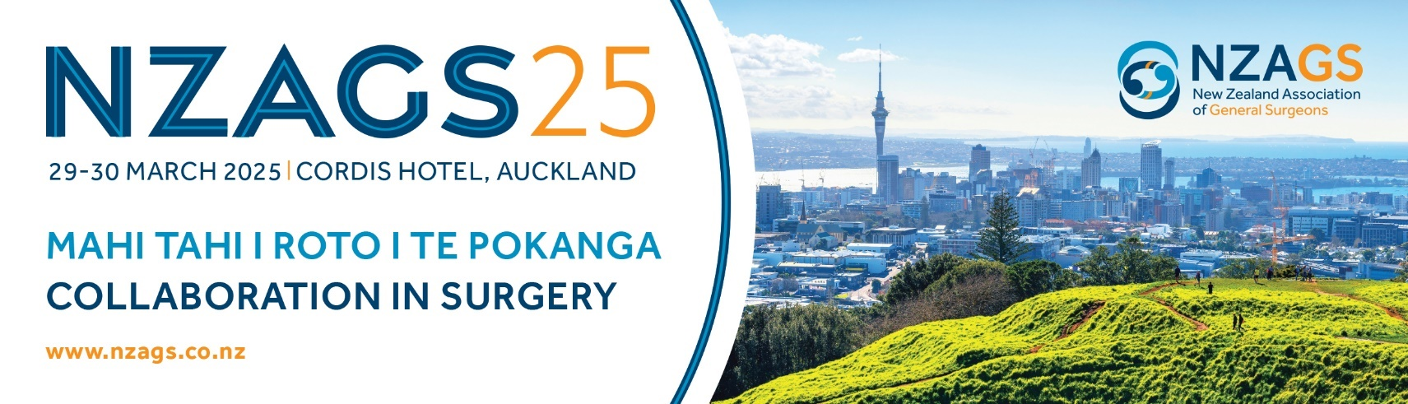

CALL FOR ABSTRACTS

The NZAGS Conference Committee would like to thank you for your interest in submitting an abstract for the 2025 ASM to be held at the Cordis Hotel, Auckland, 29-30 March 2025.

Abstracts are invited for Oral Presentations or Poster Display. If your abstract is not chosen for an oral presentation, you may be offered the opportunity to display a poster.

If you wish to submit an abstract for consideration by the Committee, you must also register to attend the Conference (full conference registration). You can register online at https://www.nzags.co.nz/

Deadlines for Submission
- Abstract Submission Open – Monday 16 September 2024
- Registration Open – Monday 18 November 2024
- Abstract Submission Close – 6.00pm Friday 24 January 2025
- Notification of Abstracts: - Monday 24th February 2025
- Early bird Registration Close – Monday 17th March 2025

If you have any concerns or queries, please reach out to the conference organisers Kimberley at conference@nzags.co.nz

Please ensure you read the following information before submitting an abstract.

PRESENTATIONS

Oral Presentations:

The oral presentation categories include:
- Basic Science Research
- Clinical Research

A maximum of 12 oral presentations will be eligible for the awards. The oral presentation timing will be determined by the Committee, but is likely to be 10 minutes (8 minutes presentation, 2 minutes Q&A and changeover). Standard audio-visual equipment will be provided: lectern, microphone, PC laptop, data projector and screen.

We require your PPT Presentation by Wednesday 12 March 2025 to kimberley@nzags.co.nz

Poster Presentations:

The poster presentation categories include:
- Basic Science Research
- Clinical Research
- Case Studies

Only the Basic Science Research and Clinical Research posters will be eligible for the poster awards, however case report poster presentations are encouraged to support an educational section.

Posters eligible for the awards:
- Will be capped at 12.
- We require a PDF of the poster to be provided by Wednesday 12 March 2025 to kimberley@nzags.co.nz.
- Must be available to discuss their research (concisely) at the conference, usually at lunchtime 12.30pm, 5 minutes in total (3 minutes presenting, 2 minutes for Q&A).

Posters not eligible for the awards:
Poster may be accepted as case studies. These posters are not available for the award and considered display only. If a case series, retrospective review is intended to be presented along with the abstract, a complete list of references used for the research must be provided. It is expected a case series, retrospective review will have a component equivalent to a formal review of the subject.

Poster Instructions:

- Your Poster should be A0 size – portrait orientated (841mm wide by 1189mm high).

- Your Poster may be laminated or printed on tear-free paper, and the text should be in a font of sufficient size for easy reading at a distance of 1 metre.

- The poster boards will be Velcro-sensitive, please bring Velcro hooks to attach your poster to the board. Sticky tape and other forms of adhesive won’t work on the fluffy board surface.

- Posters must be brought with you to the conference and erected on Saturday 29 March 2025, prior to
8.30am.

- You will be required to stand beside your poster during the lunch break (12.30pm -TBC see the programme) on Saturday 29 March 2025, to answer questions from delegates and judges if applicable.

PRESENTATION AWARDS

NZAGS Awards
During the online submission process, you will need to select which Award category best describes your research.
- Best Oral Presentation by a registrar enrolled in a higher degree* $700
- Best Oral Presentation by a registrar not enrolled in a higher degree $700
- Best Poster Presentation by a registrar enrolled in a higher degree* $300
- Best Poster Presentation by a registrar not enrolled in a higher degree $300
*Research must have been done as part of a higher degree.

NZAGS AWARD TERMS AND CONDITIONS
Abstracts must be submitted via the NZAGS Conference website. The applicant must research, write and present their own research. The research carried out must indicate if it was completed as part of a Higher Degree or not. Presenter must indicate if the research is clinical or science based. All NZAGS SET trainees must have received prior approval for their research topic from the NZAGS Education Committee.
Applicants must register for and attend the conference to present their research.

THE DAMIEN MOSQUERA RESEARCH AWARD
In remembrance each year at the NZAGS meeting, a prize will be offered for the best submitted paper or poster from a regional centre. The prize of $700 will be awarded each year to the primary author of a paper or poster presented at the meeting, that best epitomises the scientific rigour and endeavour that
defined Damien’s career. Damien was consultant surgeon from Taranaki/New Plymouth who was on the New Zealand General Surgery Training Committee up until his untimely death in 2014. His time on the committee was defined by his steadfast commitment to encouraging trainees into robust research projects, and many such projects came out of Taranaki Base Hospital as a result of his efforts. Amongst many things, Damien showed us that good quality, contributory research doesn’t always come from the big metropolitan centres. This award commemorates his enormous contribution to training in General Surgery in this country

THE DAMIEN MOSQUERA RESEARCH AWARD TERMS AND CONDITIONS
- oral presentation or poster considered in equal competition
- must be accepted for presentation at the NZAGS annual meeting
- must be from data generated at a New Zealand centre other than Auckland, North Shore, Middlemore, Waikato, Wellington, Christchurch or Dunedin.
- only first author is eligible and must present the paper or poster at the NZAGS meeting
- fellows are not eligible, but non-SET trainees are (e.g. house surgeons, junior registrars)
- literature reviews are not eligible
- meta-analyses and systematic reviews are only acceptable when the research supervisor is from a provincial centre
- submissions for this award are also eligible for consideration for the established registrar conference prizes, if applicable.

GENERAL INFORMATION

General specifications are:

- Length: 300 words or less, excluding presenters and department
- Text should be single spaced.
- Limit the number of authors to no more than 7
- Do not indent paragraphs
- All abstracts must be submitted in English Your abstract should contain the following:
- Title: Sentence Case (not all capitals)

- Authors / Presenters: Sentence Case. Authors’ names should be supplied in the surname-last format and should be in initial capital/lower case, not all capitals. All affiliations must state the authors’ institution, city and country. e.g.:
Brown, G., ABC University, Auckland, New Zealand Smith, A., XYZ Hospital, Christchurch, New Zealand

- Body of Abstract: Sentence Case. Your headings "Introduction (including the study hypothesis), Aims, Methods, Results, Conclusions" need to be bold. Each heading should be its own paragraph. Sub headings may be used but should not be given separate paragraphs.

- References: References (maximum of two) in a list following the abstract. The style of the references should follow either the Harvard or APA method.
- Abbreviations may be used but must be spelt out in full at the first mention followed by the abbreviation in parentheses.

INSTRUCTIONS FOR SUBMITTING AN ABSTRACT

- Go to https://www.nzags.co.nz/
- Click on the “Call for Abstracts” page, and complete the form
- Set up a profile for yourself and follow all the online instructions
- Complete your abstract (e.g. in a word document), copy and paste it into the text box as part of the online submission process when requested.

You will receive confirmation by email that the abstract has been received. If you do not receive a confirmation, please contact our PCO (Professional Conference Organiser) at Kimberley@nzags.co.nz .

